Requirements

UI Requirements:

1.Login Screen:

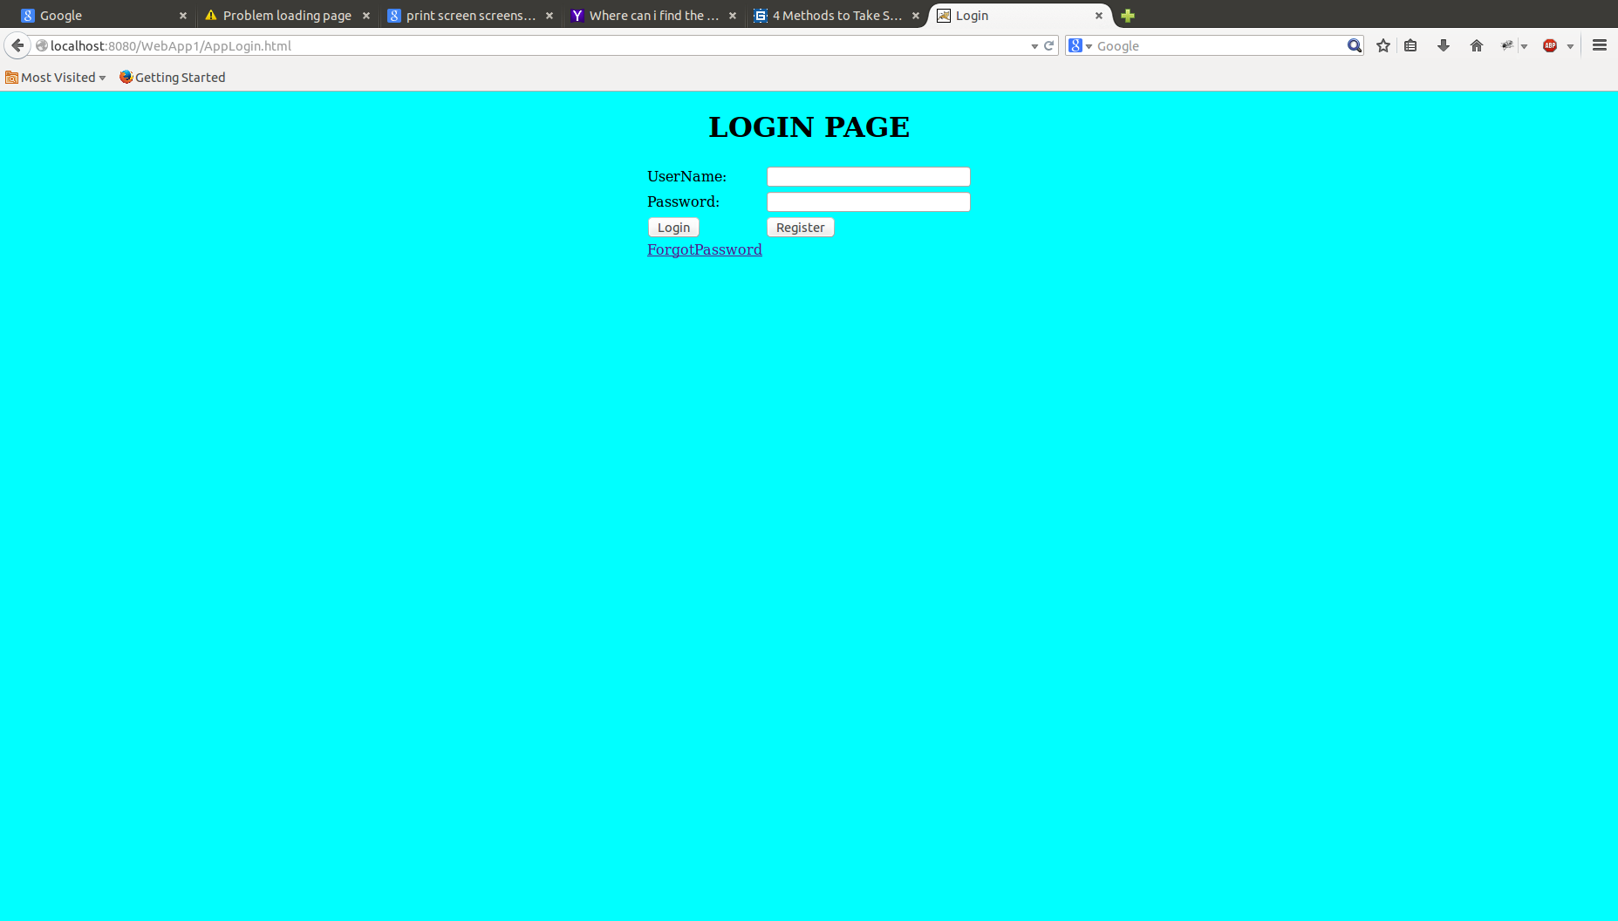

* User need to provide the valid credentials to enter into the application.
* On clicking register button it should navigate to register page.

2.Registration Screen:

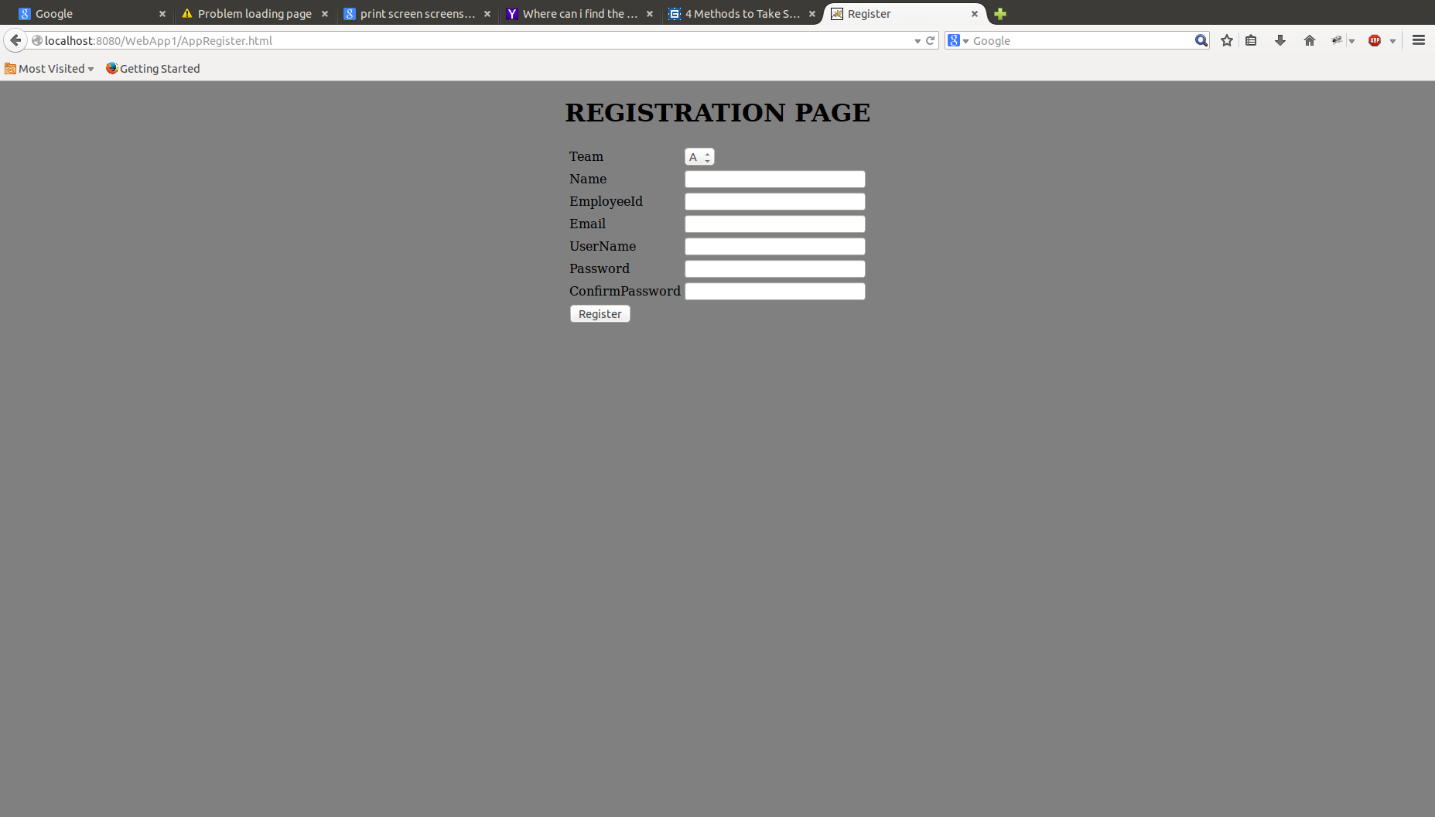

* Here the user need to provide the above details to register.
* When he clicks on register button it should navigate to login page.

3.Admin Page:

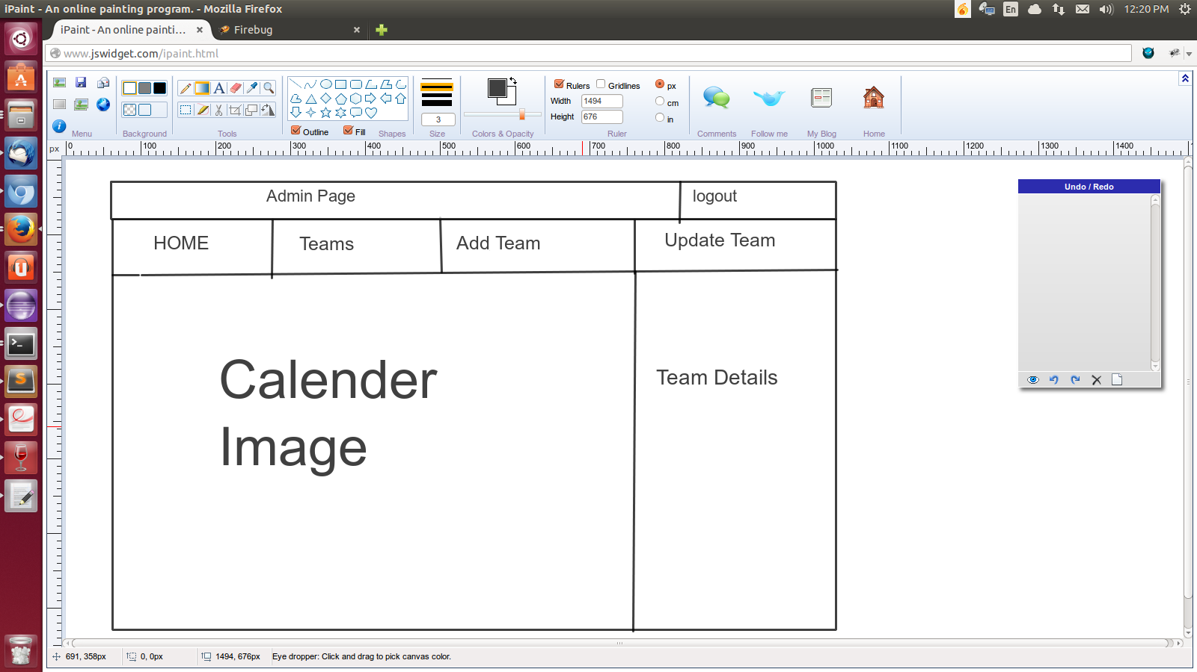

* When admin logged in successfully he should navigate to admin page.
* The admin can perform operations like add team and update the team.

4.User Page:

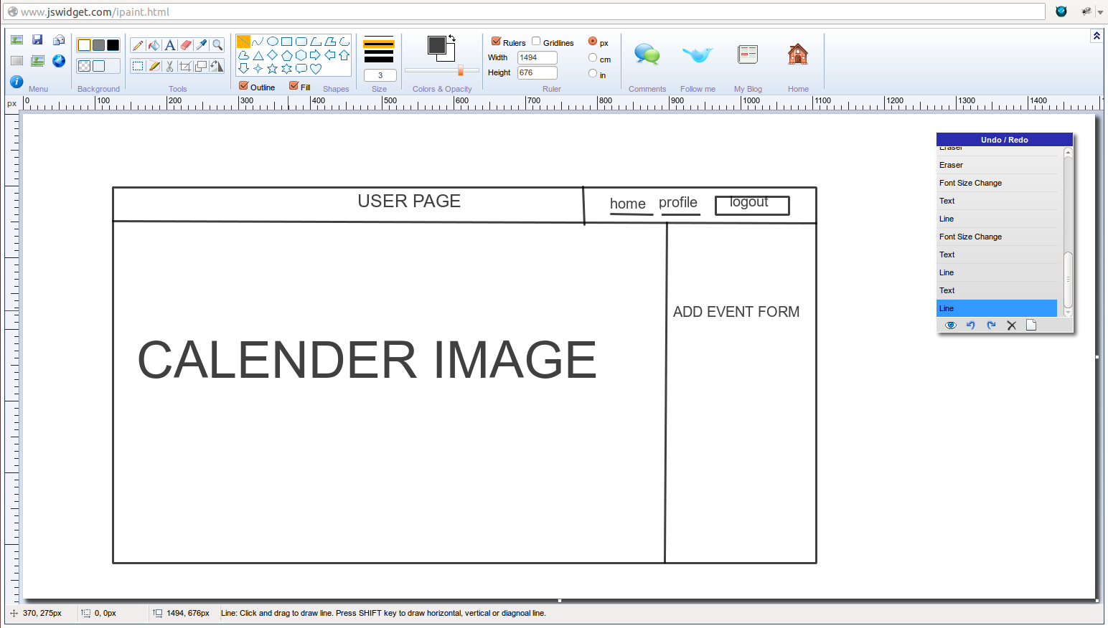

* When user logged in successfully he should navigate to user page.
* Here the user can view the events, add the new event and update.
* Here user can update his profile.